***Filters and edge detection***

***Sobel Filter:***

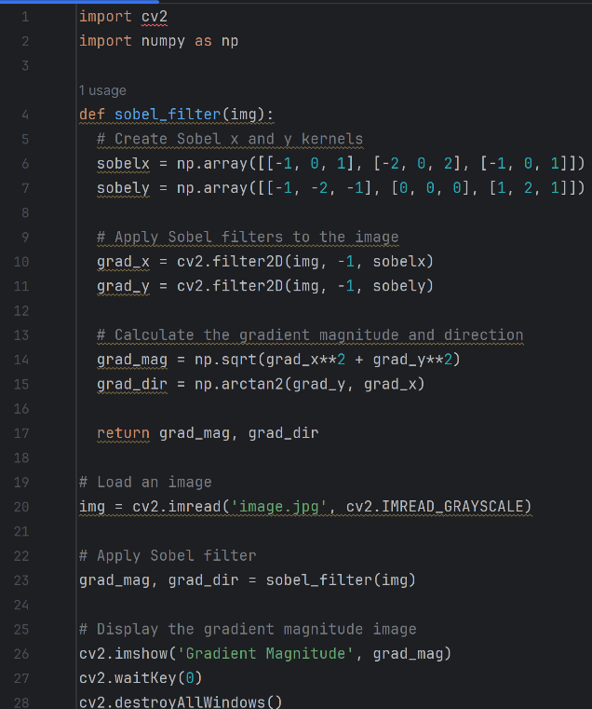The Sobel filter, also known as the Sobel operator, is an edge detection technique in image processing and computer vision. It is used to identify gradients in an image, which helps in edge detection. It is a 2D convolution kernel that is applied to an image to approximate the gradient of the intensity function. The gradient is a vector that points in the direction of the steepest ascent of the function.

The Sobel filter is a combination of two 1D filters, one that detects horizontal edges and one that detects vertical edges. It is applied to an image by convolving it with the filter. The result is an image where each pixel represents the magnitude of the gradient at that point. The direction of the gradient can be found by taking the arctangent of the y component of the gradient divided by the x component of the gradient.

***Laplacian Filter:***

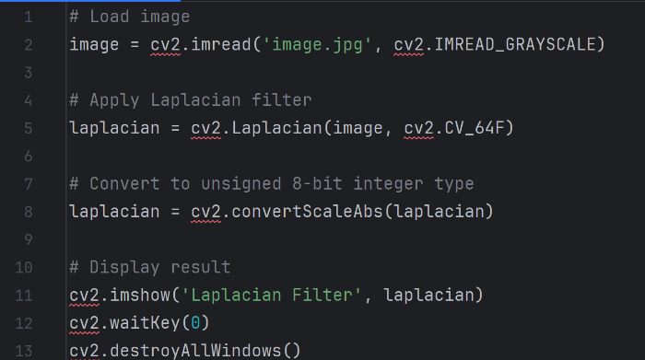The Laplacian filter is a second-order derivative filter used for detecting edges in images by highlighting regions where the intensity changes rapidly. It calculates the Laplacian, which is the sum of the second derivatives in both the x and y directions. It is particularly useful for finding edges that are not aligned with the standard coordinate axes, image enhancement, detecting blobs (regions of uniform intensity), and sometimes as a precursor to more advanced edge detection techniques like the Canny edge detector.

***Canny Edge Detector:***

The Canny edge detector is a multi-stage algorithm that detects edges in images by minimizing error rates and avoiding detection of false edges. It involves five steps: noise reduction using a Gaussian filter, gradient calculation, non-maximum suppression, double thresholding, and edge tracking by hysteresis. The result is a binary image with sharp edges, making it one of the most widely used edge detection methods. It is used in computer vision tasks, such as object detection, shape recognition, and image segmentation.

***Contours in Image Processing:***

Contours are curves that connect continuous points of the same intensity or color in an image, essentially outlining the shape of objects. Contour detection is often performed on binary images, and contours are widely used in object detection, shape analysis, and image segmentation. The algorithm for finding contours traces the boundary of an object in an image, typically after applying edge detection techniques like Canny. They are used in applications like shape analysis, object detection, and image recognition to determine the boundaries of objects and their geometric properties.

